IFRS 9 – Systemic variable calibration

Version 0.00

Forward Looking

|  |  |  |  |
| --- | --- | --- | --- |
| Version | Created / Modified | Modifications | Date |
| 0.0 | Ismail Boutaleb | Initialisation | 17/01/2018 |
| 1.0 | Arnaud Jousseaume  (Prestataire)  Ismail Boutaleb | Part II.c explanatory variables colinearity test  Part IV.a Model choices to answer recommendation IFRS9_PD_05 from validation team  Part III.b.1Specifications of economic constraints  Part III.c, details of stacking procedure  Parts III.dIV.a.5, documentation of confidence levels on prediction |  |

Table of contents

I. Purpose of this document 4

II. Regression problem 5

a. Variables to explain 5

b. Explanatory variables 5

c. Colinearity of the explanatory variables 6

III. Model design 7

a. Weak learners 7

b. Acceptance criteria 7

1. Economically viable 7

2. Statistically viable 8

c. Model averaging 9

d. Confidence levels 10

IV. Default and migration projection 12

a. Model choices 12

1. Number of variables for weak learners 12

2. Quarterly frequency 12

3. Using annual lags and returns for independent variables 12

4. No lags for target variables 12

5. Confidence levels 12

b. Model calibration corporate 12

1. Default Systemic Indicator 12

2. Migration Systemic Indicator 19

c. Model calibration Financial Institution 25

1. Default Systemic Indicator 25

2. Migration Systemic Indicator 31

V. Procedure 37

a. Model projection inputs 37

b. Model projection outputs 37

c. Outputs adjustments 37

VI. Results 38

Bibliography 39

# Purpose of this document

IFRS 9 and EBA stress tests require a forward looking / stressed estimation for default probability and LGD term structures. Starting from TTC and PIT migration matrix, CACIB developed framework for retrieving migration and default systemic indicators to summarize and quantify the stress degree of the PIT observation. These so called indicators are then projected using a satellite model with a set of macroeconomic projections given by CASA ECO for IFRS 9 impairment calculation EBA for the stress tests.

This document describes the satellite model used by CACIB, starting with the definition of the variables to explain and explanatory variables. The model design will be presented afterwards; it is based on a stacking approach on a set of candidate models. Then, model calibration results and performance analysis are illustrated. Next, calculation procedure is briefly described. Finally, projections results are presented.

# Regression problem

## Variables to explain

There are four variables to project using the satellite model:

* Credit default Systemic variable, denoted both for corporate and FI segments
* Credit migration systemic variable, denoted both for corporate and FI segments

These variables are retrieved from internal PIT default rates and migration matrices. They are consequently related to annual transitions and available quarterly since June 30th, 2006. Both indicators are defined in the document “CACIB – IFRS 9 - Forward Looking Integration to ECL”.

## Explanatory variables

All macroeconomic variables projected by CASA Eco and potentially linked to the overall economic cycle are used. Here below is a list of Bloomberg tickers downloaded quarterly since 2000.

|  |  |
| --- | --- |
| Variable | Definition |
| ACCPEMUY Index | Harmonized Index of Consumer Prices Eur |
| CPUPXYOY Index | Consumer Price Index (CPI) excluding food and energy US |
| GFRN10 Index | France Govt Oats Btan 10 Y |
| H15T10Y Index | US Treasury Yield Curve Rate T Note Constant Maturity 10 Year |
| H15T3M Index | US Treasury Yield Curve Rate T Note Constant Maturity 3 Month |
| SXXE Index | Euro Stoxx |
| US0003M Index | US Libor 3 month |
| FRGEGDPY Index | real GDP GA - France |
| GDP CYOY Index | real GDP GA – US |
| FRCPIYOY Index | CPI GA – France |
| CPI YOY Index | CPI GA – US |
| UMRTFR Index | Adjusted Unemployment rate - France |
| EUGNEMUY Index | real GDP GA - Zone euro |
| UMRTEMU Index | Unemployment rate seasonally adjusted - Zone euro |
| FRHPI Index | Federal Housing Finance Agency FR House Price Index Purchase Only |
| USURTOT Index | US Unemployment Rate Total In Labor Force |
| M2 Index | Federal Reserve Money Supply M2 |
| FDTR Index | Central Bank rate- US |
| HPIMLEVL Index | Federal Housing Finance Agency US House Price Index Purchase Only |
| NFP TYOY Index | US Employees on Nonfarm Payrolls Total |
| SPX Index | S&P500 |
| BDIY Index | Baltic Dry Index |
| CNFREXPY Index | China Export Trade (Annual YoY %) |
| OCONTWLD Index | Oil world consumption |
| USCRWTIC Index | Oil price WTI |
| tedSpread | Spread between Libor and government rates 3M |

All these macroeconomic variables are passed in levels and returns along with their lags (1 and 2 year’s lags). A variable with Bloomberg ticker denoted "ticker Index" leads to 6 different variables:

* L0.lvl.ticker.Index: The initial variable.
* L0.rdt.ticker.Index: The log-return of the initial variable.
* L1.lvl.ticker.Index: The initial variable 1 year lag.
* L1.rdt.ticker.Index: The log-return 1 year lag.
* L2.lvl.ticker.Index: The initial variable 2 years lag.
* L2.rdt.ticker.Index: The log-return 2 years lag.

The number of potential explanatory variables, including transformed variables, is 216. This is given by (number of transformations) times 26 (the number of initial variables).

## Colinearity of the explanatory variables

A regression cannot be performed with collinear explanatory variables. To ensure that no colinearity is present between explanatory variables, each explanatory variable within a given model is regressed on the others. For example, for a model with three explanatory variables , the following regressions are computed:

The Variance Inflation Factor (VIF)[1] is a colinearity indicator. It is calculated for each of those three regressions.

* When VIF is under 5, the model does not cause any colinearity problem. It is accepted.
* When VIF is above 10, the model does cause a colinearity problem. It is rejected.
* When VIF is between 5 and 10, an intervention to the model is required if the model weight is predominant.

Current used models show non-significant contribution from a flagged collinear model. Indeed, only one model has sub-models with potential colinearity: the Z Migration IF model. Two of the sub-models have a VIF between 5 and 10 with a cumulated Stacking weight below 10%.

# Model design

The model used could be described as a generic supervised model. It is an averaging model. The principle is based on testing numerous weak learners, which consist on multiple linear regression models and ranking them using economic and statistical acceptance criteria and quantitative metrics of performance. The final model is a weighted average of the accepted weak learners.

This section aims to be generic, for this model could be applied to other purposes. It describes the principles of the model and details how variables combinations are tested (weak learners), the acceptance criteria and averaging technics used to aggregate predictions. Modeling choices specific to projecting systemic default and migration indicators are detailed in section IV.

A synthetic scheme is showed in Figure 2.

## Weak learners

An exhaustive research approach is used on a fixed number of variables .

Let’s take for an illustrative purpose, each possible combination of 1, 2, 3 or 4 variables give birth to a weak learner, which is a multiple linear regression model with an intercept. Each variable to explain will be regressed to a number of of possible combinations; where is the number of explanatory variables.

## Acceptance criteria

Not all weak learners tested are significant or economically viable. Every model has to respect all the following criteria in order to be retained.

### Economically viable

One expects an economic sign of the parameters. For example, if the regression parameter between the systemic variable and the GDP is negative, the model is rejected.

Here below are the economic signs expected.

* +1 means a positive
* -1 means a negative
* 0 means no sign expected, the test does not reject a model because of this variable

|  |  |  |
| --- | --- | --- |
| **Variable** | **Definition** | **Sign** |
| **ACCPEMUY** | Harmonized Index of Consumer Prices Eur YoY | 0 |
| **BDIY** | Baltic Dry Index | -1 |
| **CNFREXPY** | China Export Trade (Annual YoY %) | -1 |
| **CPI YOY** | CPI GA Consumer Price Index - US | 0 |
| **CPUPXYOY** | Consumer Price Index (CPI) excluding food and energy US YoY | 0 |
| **Ecart taux long court USD** | Spread between H15T10Y and H15T3M. Long and short US Triesury yield rates | 0 |
| **EUGNEMUY** | real GDP GA - Zone euro | -1 |
| **FDTR** | Central Bank rate- US | 0 |
| **FRCPIYOY** | CPI Consumer Price Index GA - France | 0 |
| **FRGEGDPY** | real GDP GA – France | -1 |
| **FRHPI** | Federal Housing Finance Agency FR House Price Index Purchase Only | 0 |
| **GDP CYOY** | real GDP GA – US | -1 |
| **GFRN10** | France Govt Oats Btan 10 ans | 1 |
| **H15T10Y** | US Treasury Yield Curve Rate T Note Constant Maturity 10 Year | 1 |
| **H15T3M** | US Treasury Yield Curve Rate T Note Constant Maturity 3 Month | 1 |
| **HPIMLEVL** | Federal Housing Finance Agency US House Price Index Purchase Only | 0 |
| **NFP TYOY** | US Employees on Nonfarm Payrolls Total | -1 |
| **OCONTWLD** | Oil world consumption | 0 |
| **SPX** | S&P500 | -1 |
| **SXXE** | Euro Stoxx | -1 |
| **tedSpread** | Spread between Libor and governement rates 3M | 0 |
| **UMRTEMU** | unemployment rate seasonally adjusted - Zone euro | 1 |
| **UMRTFR** | Corrected unemployment rate - France | 1 |
| **US0003M** | US Libor 3 month | 1 |
| **USCRWTIC** | Oil price WTI | 0 |
| **USURTOT** | US Unemployment Rate Total In Labor Force | 1 |

Table 1: economic constraints on IFRS 9 models

Note that,

* The table above is an illustrative example.
* The actual signs are specified either by CASA ECO for IFRS 9 purposes or by EBA through STAMP€ [1] for stress tests purposes when they produce a macroeconomic forecast for a variable. This is an assumed difference between stress tests and IFRS 9 frameworks.
* If the sign is not specified by CASA ECO (or EBA according to the context) no constraint is specified (sign = 0).
* According to CASA ECO, sign restriction should be applied to the variable and its transformation (lags and the delta / return).
* If CA-CIB uses some predictors which are not on the scope of variables forecasted by CASA ECO (or EBA according to the context), the relevance of the sign constraints will be discussed with CA-CIB experts. Moreover, CA-CIB will ask for opinion of risk analysts on the outcome of the modeling study.
* According to CASA ECO, signs could change over time, as the economic context changes over time.

### Statistically viable

A weak leaner is a linear regression. Consequently a set of statistical tests, derived from linear regression hypothesizes, are performed on each weak learner. A confidence level is common to all the statistical tests and is dependent on the data. A high confidence level (99%) selects only highly significant candidates in a small number or sometimes no candidate at all, whereas a low confidence level (75%) ensures that at least some models are kept. The compromise between the number of accepted candidates and their significance is obtained through experimentation and documented in part IV.

* Parameters significance: Student test, Fisher test
* Residuals Normality: Shapiro Wilk
* Residual autocorrelation: Box test
* Homoscedasticity: Goldfeld Quandt test, Studentized Breusch Pagan test
* Parameters stability: Cusum test

## Model averaging

The model used is a weighted average above all accepted weak learners. The weights are defined using a stacking technic consisting in minimizing out of sample error. The following technics have been tested.

* Arithmetic average:
  + Pros:
    - Simplicity
    - Fast computing
  + Cons:
    - Lack of performance
    - Sensitivity to adding or removing a variable to the initial pool
* Bayesian model averaging:
  + Procedure description: Bayesian theory gives a closed formula of the probability of each weak learner given the observed data. This formula is dependent on the likelihood of the weak learner. The weight of each weak learner’s prediction is its probability given the data.
  + Pros:
    - Closed formula derived from Bayesian theory
    - Fast computing
  + Cons:
    - High model risk caused by weights concentration on very few models (1 or 2)
    - Sensitivity to adding or removing a variable to the initial pool
    - Assumption of homogeneous a priori probability
    - Assumption of Gaussian distribution
* Stacking:
  + Procedure description:
    - For each weak learner, a K fold cross validation is run over available dates. For each fold, points are held out of training. These points are used as a test sample. The prediction on the test sample is called the out of sample prediction of the fold. For IFRS 9 purpose corresponding to 3 years of test.
    - Running the calibration on the train and out of sample prediction on the test sample for each fold allows measuring an out of sample prediction on the entire set of dates.
    - The stacking weights are defined as the weights that minimize the RMSE between the weighted average out of sample prediction and the observation.
  + Pros:
    - Best performance (see for example Figure 7 and Figure 8)
    - No sensitivity to adding or removing a variable to the initial pool
    - Fewer model risk: Weights are better distributed (see Figure 1)
  + Cons:
    - Heavy computations

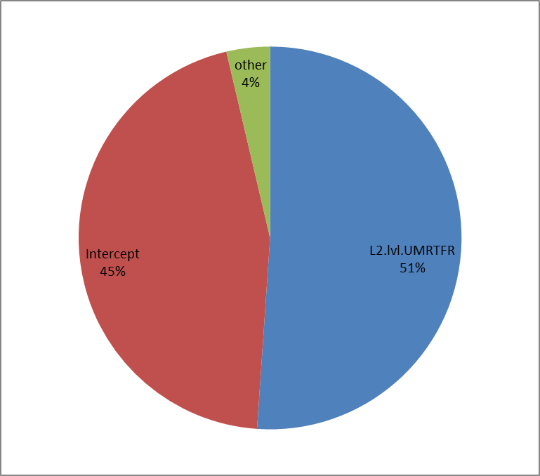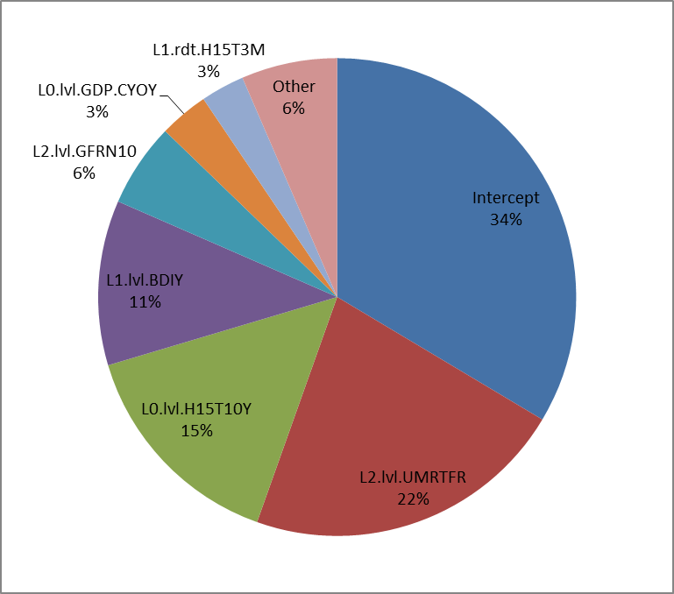

Stacking

BMA

Figure 1: Variables contribution to the aggregated model (corporate default systemic indicator example). Stacking relies on more variables whereas BMA implies a higher model risk by relying solely on a unique variable.

## Confidence levels

In order to limit risk uncertainty, a confidence interval could be used for the prediction. This interval’s assessment is based on the standard deviation of the out of sample error according to a specified confidence level .

A K fold cross validation is done for the set of accepted weak learners; each fold is 3 consecutive years of test and the remaining years for train. Weak learners are trained on the train folds and produce a prediction on the test fold. These predictions are called out of sample predictions on the fold. Iterating the process over all folds allows reconstituting an out of sample prediction on the entire historic. Out of sample prediction is compared to the actual observation and an out of sample error is defined. The variance of this error depicts the model’s uncertainty when dealing with test data. A confidence prediction is therefore defined as the model’s unbiased prediction translated by to the conservative way. is the Gaussian percentile with level .

* **Conservative projection:**
* A confidence level is set on the projection to assess the model uncertainty (75% for FI and 90% for Corporates)
* **Significance Tests :**
* Parameters significance: Student test, Fisher test
* Residuals Normality: Shapiro Wilk
* Stationarity: Augmented Dickey Fuller
* Residual autocorrelation: Box test
* Homoscedasticity: Goldfeld Quandt test, Studentized Breusch Pagan test
* Parameters stability: Cusum test
* **Economic Sign :**
* Restrictive sign for regression**.**

Figure 2: Synthetic scheme to describe the model design

Projected Systemic Indicator

Projection 1

Projection 4

Projection 6

Projection 8

Projection i

Model 1

Model 4

Model 6

Model 8

Model i

Model 1

Model 2

Model 3

Model 4

Model 5

Model 6

Model 7

Model 8

Model i-1

Model i

Historical Macroeconomic Variables

Historical Systemic Indicator

**Significance Tests**

**Economic Sign**

**Accepted models**

**Exhaustive Combinations of models with less than four variables**

Stacking

Weighted average projection

Weights are calibrated to minimize Out Of Sample Error

**Automatic Rejection tests**

**Satellite Model algorithm to explain Systemic Indicator using Macroeconomic Variables**

# Default and migration projection

## Model choices

The number of observations is the main constraint in this framework (11 years observations in the whole calibration and 8 years for out of sample calibrations). Therefore, some choices are made in order to limit model complexity and increase the training observations. They are summarized in this section.

### Number of variables for weak learners

The following procedure is done in order to select the number of variables for weak learners.

Start with p = 2.

If the number of accepted weak learners is sufficient (>50) Then stop. See acceptance criteria below.

Else increase p by 1

Limit p to a maximum of 4

MQP experience shows that the procedure above leads to between 3 and 4. This is backed up by EBA STAMP€ [1] which asks for a maximum number up to 4.

The limit, is done to ensure a *reasonable and* *possible* number of models tested. For instance, leads to more than 750 million models to test, which is over the limit of the available computing power.

### Quarterly frequency

Using quarterly observed variables instead of annually, even if all used variables are annual leading to overlapping (Equity returns, total consumptions, GDP increase, average equity levels, Default rates, Migration matrices, , ... are calculated over 1 year). This choice allows calibrating on 44 observations and 32 observations for out of sample measures. This choice is a recommendation from CACIB auditors.

### Using annual lags and returns for independent variables

Variables transformations (annual lags and returns) are created and passed as candidates for model combinations. Because variables are annual (Equity returns, total consumptions, GDP increase, average equity levels are calculated over 1 year) the minimum lag authorized to avoid colinearity is 1 year.

### No lags for target variables

The use of 1 year lags for and leads to a loss of 4 observations. Considering an Out Of Sample calibration is done over 32 points, a use of lag leads to a significant loss amount of data.

### Confidence levels

Confidence levels on prediction are applied to Corporate 90 % and Financial Institutions 75%.

## Model calibration corporate

### Default Systemic Indicator

This section aims at describing model Default Systemic Indicator calibration and showing its performance.

The final model equation is given in the table below.

|  |  |  |
| --- | --- | --- |
| Variable | Description | Coefficient (Weighted average) |
| Intercept | - | -0.8197 |
| L2.lvl.UMRTFR | Corrected unemployment rate – France | -0.0586 |
| L0.lvl.H15T10Y | US Treasury Yield Curve Rate T Note Constant Maturity 10 Year | 0.134 |
| L1.lvl.BDIY | Baltic Dry | 0.0001 |
| L2.lvl.GFRN10 | France Govt Oats Btan 10 Y | 0.0451 |
| L0.lvl.GDP.CYOY | US GDP | 0.0578 |
| L1.rdt.H15T3M | US Treasury Yield Curve Rate T Note Constant Maturity 3 Month | 0.2005 |
| L2.lvl.FRCPIYOY | CPI GA – France | 0.0228 |
| L0.rdt.SPX | S&P 500 | 0.6723 |
| L1.lvl.H15T10Y | US Treasury Yield Curve Rate T Note Constant Maturity 10 Year | 0.0098 |
| L2.lvl.CPUPXYOY | Consumer Price Index (CPI) excluding food and energy US YoY | -0.0135 |
| L1.rdt.BDIY | Baltic Dry | 0.074 |
| L2.lvl.ACCPEMUY | Harmonized Index of Consumer Prices Eur YoY | 0.0058 |
| L2.rdt.H15T10Y | US Treasury Yield Curve Rate T Note Constant Maturity 10 Year | 0.0217 |
| L1.lvl.tedSpread | Spread between libor and government rates 3M | -0.0089 |
| L1.lvl.CNFREXPY | China Export Trade (Annual YoY %) | 0.0003 |
| L2.lvl.US0003M | US Libor 3 month | -0.0007 |
| L0.rdt.NFP.TYOY | US Employees on Nonfarm Payrolls Total | 0.0214 |
| L2.rdt.ACCPEMUY | Harmonized Index of Consumer Prices Eur YoY | 0.0007 |

16 models were accepted with a 95% confidence level using statistical tests and economic constraints.

|  |  |  |  |  |  |  |  |
| --- | --- | --- | --- | --- | --- | --- | --- |
| Model name | RMSE | R² | R² adj | AIC | BIC | p-value test Fisher | max(p-value) test Student |
| ~L0.rdt.SPX +L1.lvl.BDIY +L1.rdt.H15T3M | 0.18 | 0.84 | 0.83 | -24.82 | -16.25 | 6.66E-15 | 1.39E-07 |
| ~L0.lvl.GDP.CYOY +L0.lvl.H15T10Y +L2.lvl.GFRN10 | 0.19 | 0.78 | 0.77 | -12.11 | -3.55 | 2.00E-12 | 3.12E-05 |
| ~L1.rdt.BDIY +L1.rdt.H15T3M +L2.lvl.UMRTFR | 0.20 | 0.86 | 0.85 | -29.36 | -20.79 | 8.88E-16 | 1.27E-10 |
| ~L0.lvl.GDP.CYOY +L0.lvl.H15T10Y +L0.lvl.HPIMLEVL | 0.23 | 0.76 | 0.75 | -8.41 | 0.16 | 1.05E-11 | 1.79E-04 |
| ~L0.rdt.SXXE +L1.rdt.SXXE +L2.lvl.H15T10Y | 0.25 | 0.68 | 0.66 | 3.52 | 12.09 | 2.17E-09 | 9.69E-06 |
| ~L1.lvl.H15T10Y +L2.lvl.US0003M +L2.rdt.ACCPEMUY | 0.27 | 0.64 | 0.61 | 8.68 | 17.24 | 2.16E-08 | 1.49E-03 |
| ~L0.lvl.H15T10Y +L0.rdt.NFP.TYOY +L2.rdt.H15T10Y | 0.29 | 0.74 | 0.71 | -3.71 | 4.86 | 8.60E-11 | 1.11E-03 |
| ~L1.lvl.H15T10Y +L2.lvl.ACCPEMUY +L2.lvl.CPUPXYOY | 0.30 | 0.69 | 0.66 | 3.40 | 11.96 | 2.06E-09 | 2.57E-05 |
| ~L0.rdt.FDTR +L1.lvl.NFP.TYOY +L1.rdt.H15T3M | 0.30 | 0.66 | 0.63 | 6.83 | 15.40 | 9.49E-09 | 8.29E-05 |
| ~L1.rdt.BDIY +L1.rdt.H15T3M +L2.lvl.UMRTEMU | 0.33 | 0.82 | 0.81 | -20.24 | -11.67 | 5.22E-14 | 1.59E-07 |

The used model is a weighted average stacking of the models above. Table 2 lists the most weighted models when aggregating models using Stacking. Note that individual R² are fewer than 86% whereas the aggregated model reaches 88% R².

|  |  |  |  |  |  |  |  |  |
| --- | --- | --- | --- | --- | --- | --- | --- | --- |
| Model Name | Stacking weight | RMSE | R² | R² adj | AIC | BIC | Fisher Snedecor PValue | Max Student PValue |
| ~L0.rdt.SPX + L1.lvl.BDIY + L1.rdt.H15T3M | 28% | 18% | 84% | 83% | -24.82 | -16.25 | 6.66E-15 | 1.39E-07 |
| ~L0.lvl.GDP.CYOY + L0.lvl.H15T10Y + L2.lvl.GFRN10 | 25% | 19% | 78% | 77% | -12.11 | -3.55 | 2.00E-12 | 3.12E-05 |
| ~L1.rdt.BDIY + L1.rdt.H15T3M + L2.lvl.UMRTFR | 15% | 20% | 86% | 85% | -29.36 | -20.79 | 8.88E-16 | 1.27E-10 |
| ~L0.lvl.H15T10Y + L0.rdt.NFP.TYOY + L2.rdt.H15T10Y | 14% | 29% | 74% | 71% | -3.71 | 4.86 | 8.60E-11 | 1.11E-03 |
| ~L1.lvl.BDIY + L1.rdt.H15T3M + L2.lvl.FRCPIYOY | 12% | 36% | 76% | 74% | -7.86 | 0.70 | 1.34E-11 | 3.80E-04 |
| ~L0.lvl.H15T10Y + L1.lvl.CNFREXPY + L1.lvl.tedSpread | 3% | 43% | 64% | 61% | 8.76 | 17.32 | 2.24E-08 | 2.55E-04 |
| ~L1.lvl.H15T10Y + L2.lvl.ACCPEMUY + L2.lvl.CPUPXYOY | 2% | 30% | 69% | 66% | 3.40 | 11.96 | 2.06E-09 | 2.57E-05 |
| ~L1.lvl.H15T10Y + L2.lvl.US0003M + L2.rdt.ACCPEMUY | 1% | 27% | 64% | 61% | 8.68 | 17.24 | 2.16E-08 | 1.49E-03 |

Table 2: Most weighted models after stacking procedure

Parent model could be summarized to a unique equation by averaging coefficients. Therefore, the contribution of each variable to the model could be assessed as the average contribution to the historical estimation. Figure 3 shows corporate default is mainly explained by 2 years lag French unemployment rate (22%), 10Y US treasury yield curve (15%) and 1 year lag Baltic Dry Index YoY (11%).



Figure 3: Variables contribution to the parent model after stacking aggregation

Figure 4 and Figure 5 show in sample and out of sample backtests using alternative aggregation methods. The out of sample prediction is based on a KFold bootstrapping; iteratively removing 4 successive points from the training set on which the models are recalibrated. Afterwards, prediction is done on the 4 removed points. These figures show relatively good performance between Stacking, BMA and arithmetic average when testing In Sample whereas Stacking is significantly superior on the out of sample test.

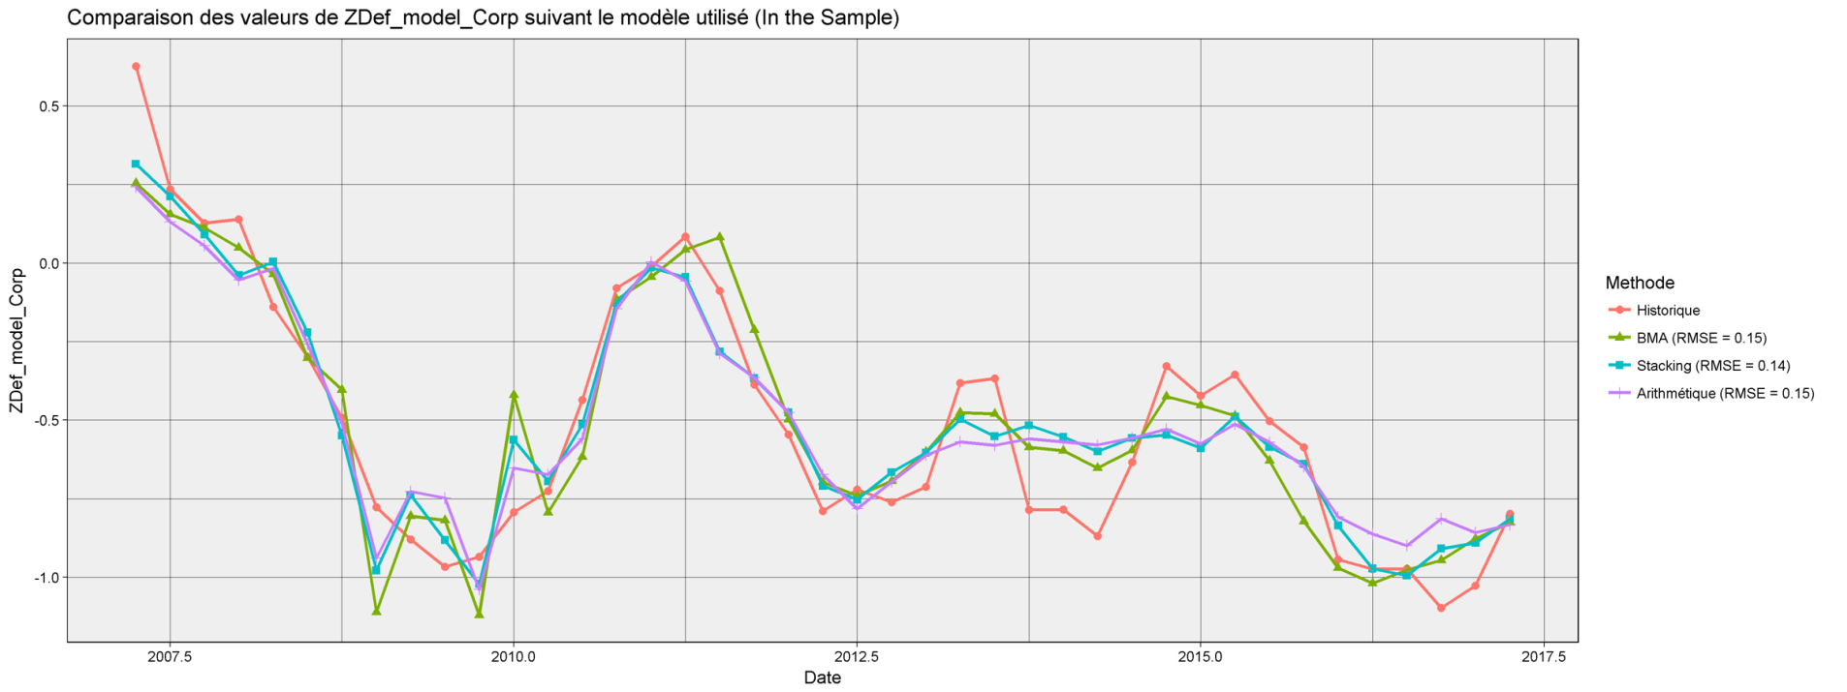

Figure 4: In SAMPLE BACKTESTS FOR CORPORATE DEFAULT SYSTEMIC INDICATOR MODELS USING DIFFERENT AGGREGATION METHODS.

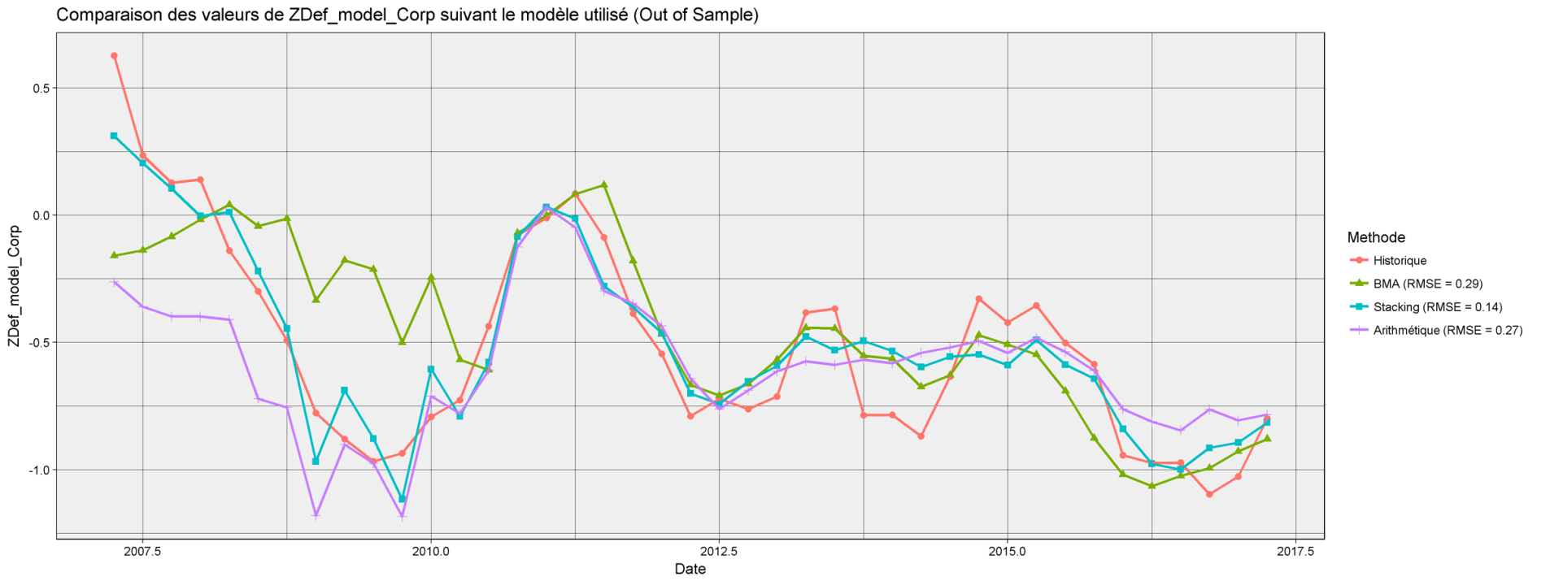

Figure 5: Out of sample backtests for corporate default systemic indicator models using different aggregation methods.

### Migration Systemic Indicator

This section aims at describing model corporate migration Systemic Indicator calibration and showing its performance.

The final model equation is given in the table below.

|  |  |  |
| --- | --- | --- |
| Variable | Description | Coefficient (Weighted average) |
| Intercept | - | 1.177 |
| L0.rdt.ecarttauxlongcourtUSD | Spread between 10Y and 3M US trasury bond yields | -0.1841 |
| L0.rdt.FDTR | Central Bank rate- US | 0.0068 |
| L0.lvl.CPI.YOY | CPI GA – US | 0.0671 |
| L1.lvl.ecarttauxlongcourtUSD | Spread between 10Y and 3M US trasury bond yields | 0.0138 |
| L1.lvl.NFP.TYOY | US Employees on Nonfarm Payrolls Total | -0.0315 |
| L2.lvl.H15T3M | US Treasury Yield Curve Rate T Note Constant Maturity 3 Month | 0.004 |
| L2.lvl.NFP.TYOY | US Employees on Nonfarm Payrolls Total | -0.0591 |
| L0.lvl.BDIY | Baltic Dry Index | -0.0001 |
| L0.lvl.H15T3M | US Treasury Yield Curve Rate T Note Constant Maturity 3 Month | 0.0349 |
| L0.lvl.CNFREXPY | China Export Trade (Annual YoY %) | 0.0055 |
| L2.rdt.GFRN10 | France Govt Oats Btan 10 Y | -0.0297 |
| L2.rdt.tedSpread | Spread between Libor and government rates 3M | -0.0342 |
| L0.lvl.HPIMLEVL | Federal Housing Finance Agency US House Price Index Purchase Only | 0.0022 |
| L0.lvl.tedSpread | Spread between Libor and government rates 3M | -0.036 |
| L0.rdt.UMRTEMU | unemployment rate seasonally adjusted - Zone euro | -1.0167 |
| L1.lvl.FRHPI | Federal Housing Finance Agency FR House Price Index Purchase Only | -0.0169 |
| L0.rdt.ACCPEMUY | Harmonized Index of Consumer Prices Eur YoY | 0.0479 |
| L2.rdt.SXXE | EuroStox 50 | 0.0837 |
| L2.lvl.USURTOT | US Unemployment Rate Total In Labor Force | -0.0527 |
| L1.lvl.H15T3M | US Treasury Yield Curve Rate T Note Constant Maturity 3 Month | 0.0014 |
| L1.lvl.HPIMLEVL | Federal Housing Finance Agency US House Price Index Purchase Only | 0.0052 |
| L1.rdt.USCRWTIC | Oil price WTI | 0.0084 |
| L2.rdt.BDIY | Baltic Dry Index | -0.1956 |
| L2.lvl.UMRTEMU | unemployment rate seasonally adjusted - Zone euro | -0.0612 |
| L0.rdt.GFRN10 | France Govt Oats Btan 10 Y | 0.0423 |
| L2.lvl.CPUPXYOY | Consumer Price Index (CPI) excluding food and energy US YoY | 0.0193 |
| L0.lvl.SPX | S&P 500 | 0.0001 |
| L2.lvl.tedSpread | Spread between Libor and government rates 3M | -0.0429 |
| L2.rdt.H15T10Y | US Treasury Yield Curve Rate T Note Constant Maturity 10 Year | 0.0102 |

More than 6000 models were accepted with a 95% confidence level using statistical tests and economic constraints.

|  |  |  |  |  |  |  |  |
| --- | --- | --- | --- | --- | --- | --- | --- |
| Model name | RMSE | R² | R² adj | AIC | BIC | p-value test Fisher | max(p-value) test Student |
| ~L0.rdt.H15T3M + L0.rdt.CPI.YOY + L2.lvl.FRHPI | 0.49 | 0.61 | 0.58 | 60.66 | 69.22 | 1.24E-07 | 7.39E-03 |
| ~L2.lvl.ACCPEMUY + L2.lvl.FRHPI + L2.rdt.FRHPI | 0.52 | 0.59 | 0.56 | 62.44 | 71.01 | 2.73E-07 | 3.45E-02 |
| ~L0.lvl.CNFREXPY + L0.rdt.ecarttauxlongcourtUSD + L1.lvl.ACCPEMUY | 0.52 | 0.52 | 0.48 | 68.71 | 77.28 | 4.37E-06 | 3.15E-02 |
| ~L0.rdt.UMRTFR + L0.rdt.H15T3M + L2.lvl.UMRTEMU | 0.53 | 0.53 | 0.49 | 68.02 | 76.59 | 3.22E-06 | 3.51E-04 |
| ~L1.rdt.HPIMLEVL + L2.lvl.NFP.TYOY + L2.lvl.USURTOT | 0.53 | 0.59 | 0.56 | 62.01 | 70.58 | 2.26E-07 | 9.64E-07 |
| ~L0.rdt.ACCPEMUY + L0.rdt.ecarttauxlongcourtUSD + L1.lvl.FRHPI | 0.55 | 0.56 | 0.52 | 65.73 | 74.29 | 1.17E-06 | 7.75E-04 |
| ~L0.lvl.CNFREXPY + L1.lvl.ACCPEMUY | 0.55 | 0.46 | 0.43 | 71.91 | 78.76 | 9.18E-06 | 3.35E-04 |
| ~L0.rdt.H15T3M + L0.rdt.FRCPIYOY + L2.lvl.FRHPI | 0.55 | 0.59 | 0.55 | 62.55 | 71.12 | 2.86E-07 | 1.91E-02 |
| ~L0.lvl.CNFREXPY + L1.rdt.ACCPEMUY + L2.lvl.ACCPEMUY | 0.55 | 0.46 | 0.41 | 73.77 | 82.34 | 4.04E-05 | 1.25E-03 |
| ~L0.lvl.EUGNEMUY + L0.lvl.UMRTFR + L0.rdt.H15T3M | 0.55 | 0.57 | 0.54 | 63.91 | 72.48 | 5.23E-07 | 1.84E-04 |

Table 3: Best accepted models according to out of sample rmse (10 out of 6559) for corporate migration systemic indicator

The used model is a weighted average stacking of the models above. Table 4 lists the most weighted models when aggregating models using Stacking. Note that individual R² are fewer than 55% whereas the aggregated model reaches 65% R².

|  |  |  |  |  |  |  |  |  |
| --- | --- | --- | --- | --- | --- | --- | --- | --- |
| Model Name | Stacking weight | RMSE | R² | R² adj | AIC | BIC | Fisher Snedecor PValue | Max Student PValue |
| ~L0.rdt.ecarttauxlongcourtUSD + L2.lvl.USURTOT + L2.rdt.BDIY | 22% | 0.56 | 0.50 | 0.46 | 70.44 | 79.01 | 9.37E-06 | 3.32E-04 |
| ~L0.lvl.CPI.YOY + L0.lvl.BDIY + L1.lvl.FRHPI | 11% | 0.63 | 0.54 | 0.51 | 66.79 | 75.36 | 1.87E-06 | 1.33E-05 |
| ~L0.lvl.BDIY + L0.rdt.UMRTEMU + L2.lvl.UMRTEMU | 10% | 0.58 | 0.55 | 0.51 | 66.26 | 74.82 | 1.48E-06 | 1.05E-05 |
| ~L0.lvl.tedSpread + L1.lvl.HPIMLEVL + L2.lvl.NFP.TYOY | 9% | 0.66 | 0.53 | 0.49 | 68.02 | 76.59 | 3.23E-06 | 2.45E-02 |
| ~L0.lvl.CNFREXPY + L0.rdt.ACCPEMUY + L0.rdt.ecarttauxlongcourtUSD | 8% | 0.70 | 0.52 | 0.48 | 69.15 | 77.72 | 5.31E-06 | 9.29E-04 |
| ~L0.rdt.GFRN10 + L0.rdt.ecarttauxlongcourtUSD + L1.lvl.HPIMLEVL | 8% | 0.80 | 0.40 | 0.35 | 78.23 | 86.80 | 2.84E-04 | 2.74E-02 |
| ~L0.lvl.SPX + L0.lvl.CNFREXPY + L0.rdt.ACCPEMUY | 8% | 0.69 | 0.43 | 0.38 | 76.05 | 84.61 | 1.09E-04 | 9.88E-03 |
| ~L1.lvl.NFP.TYOY + L1.lvl.BDIY + L2.rdt.SXXE | 4% | 1.12 | 0.33 | 0.28 | 82.51 | 91.08 | 1.80E-03 | 1.74E-03 |
| ~L0.lvl.H15T3M + L0.lvl.CNFREXPY + L2.rdt.tedSpread | 3% | 1.18 | 0.43 | 0.38 | 76.21 | 84.78 | 1.18E-04 | 3.82E-02 |
| ~L0.lvl.H15T3M + L1.lvl.ecarttauxlongcourtUSD + L2.rdt.tedSpread | 3% | 1.24 | 0.55 | 0.51 | 66.33 | 74.90 | 1.53E-06 | 2.92E-04 |

Table 4: Most weighted models after stacking procedure

Parent model could be summarized to a unique equation by averaging coefficients. Therefore, the contribution of each variable to the model could be assessed as the average contribution to the historical estimation. Figure 6 shows corporate migration is mainly explained by house price index (28% French 1 year lag + 17% US 1 year lag + 7% US no lag), 2 year lag unemployment rate (7% euro zone + 6% US) and Baltic Dry Index (4%).

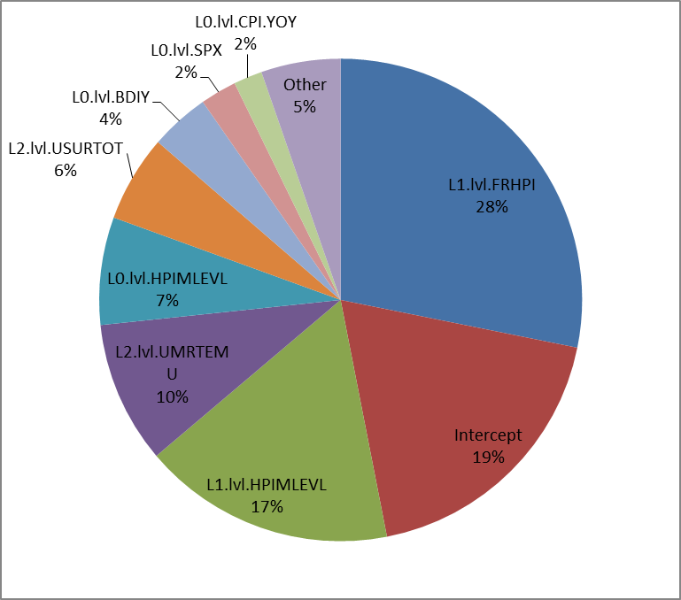

Figure 6: Variables contribution to the parent model after stacking aggregation

Figure 7 and Figure 8 show in sample and out of sample backtests using alternative aggregation methods. The out of sample prediction is based on a KFold bootstrapping; iteratively removing 4 successive points from the training set on which the models are recalibrated. Afterwards, prediction is done on the 4 removed points. These figures show relatively close performance between Stacking, BMA and arithmetic average when testing In Sample whereas Stacking is significantly superior on the out of sample test.

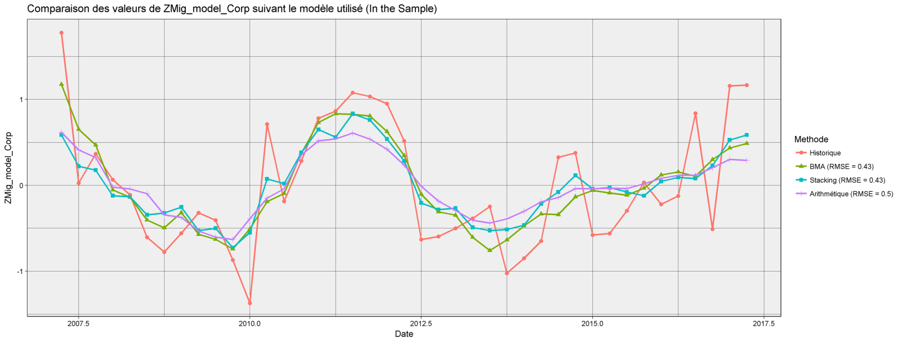

Figure 7: In sample backtests for corporate migration systemic indicator models using different aggregation methods.

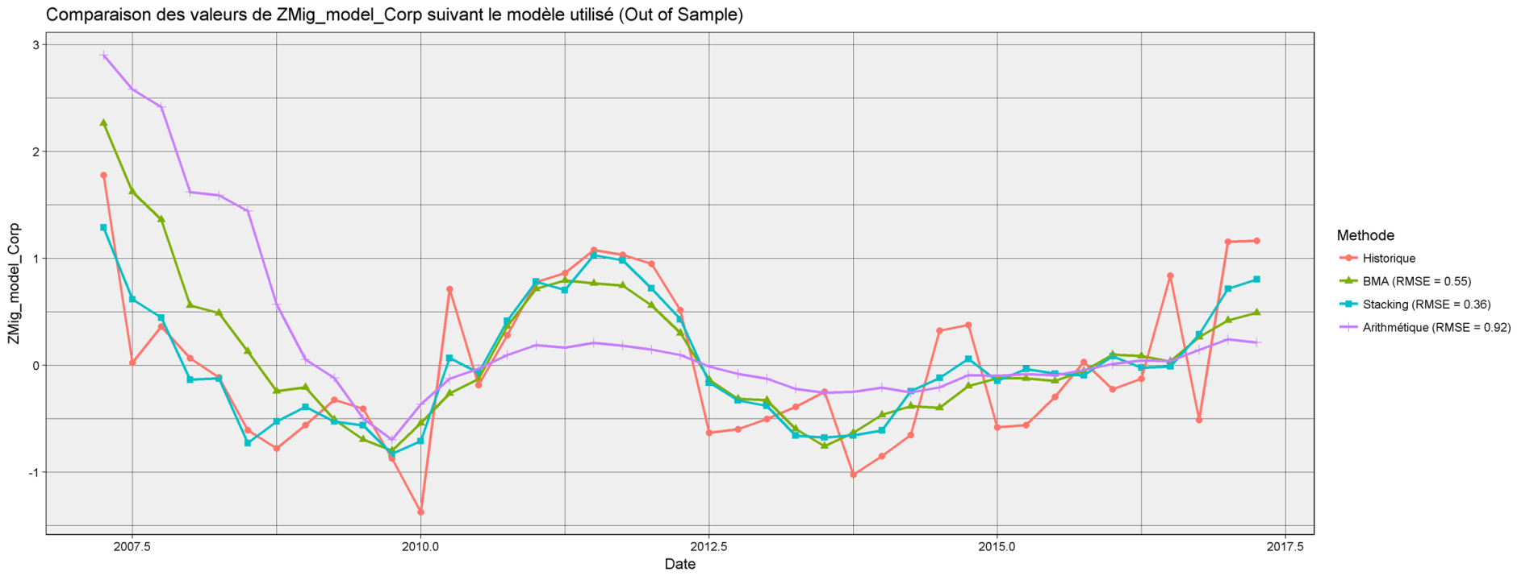

Figure 8: Out of sample backtests for corporate migration systemic indicator models using different aggregation methods.

## Model calibration Financial Institution

### Default Systemic Indicator

This section aims at describing the model for financial institutions default Systemic Indicator calibration and showing its performance.

The final model equation is given in the table below.

|  |  |  |
| --- | --- | --- |
| Variable | Description | Coefficient (Weighted average) |
| Intercept | - | 0.3323 |
| L0.lvl.ACCPEMUY | Harmonized Index of Consumer Prices Eur YoY | -0.4039 |
| L1.lvl.USCRWTIC | Oil price WTI | 0.0072 |
| L0.rdt.USURTOT | US Unemployment Rate Total In Labor Force | -0.2048 |
| L0.rdt.USCRWTIC | Oil price WTI | -0.0495 |
| L1.rdt.SPX | S&P 500 | 1.6164 |
| L2.rdt.HPIMLEVL | Federal Housing Finance Agency US House Price Index Purchase Only | 1.1662 |
| L1.lvl.US0003M | US Libor 3 month | -0.0535 |
| L0.rdt.ACCPEMUY | Harmonized Index of Consumer Prices Eur YoY | -0.0398 |
| L2.lvl.H15T10Y | US Treasury Yield Curve Rate T Note Constant Maturity 10 Year | -0.1903 |
| L2.rdt.H15T10Y | US Treasury Yield Curve Rate T Note Constant Maturity 10 Year | 0.1805 |
| L1.lvl.H15T10Y | US Treasury Yield Curve Rate T Note Constant Maturity 10 Year | 0.0396 |

17 models were accepted with a 95% confidence level using statistical tests and economic constraints.

|  |  |  |  |  |  |  |  |
| --- | --- | --- | --- | --- | --- | --- | --- |
| Model name | RMSE | R² | R² adj | AIC | BIC | p-value test Fisher | max(p-value) test Student |
| ~L2.lvl.FRCPIYOY + L2.lvl.H15T10Y + L2.rdt.H15T10Y | 0.42 | 0.75 | 0.73 | 53.04 | 61.61 | 2.41E-11 | 4.98E-02 |
| ~L0.rdt.ACCPEMUY + L2.lvl.H15T10Y + L2.rdt.H15T10Y | 0.46 | 0.76 | 0.74 | 52.02 | 60.59 | 1.52E-11 | 2.91E-02 |
| ~L0.lvl.ACCPEMUY + L0.rdt.USURTOT + L0.rdt.USCRWTIC | 0.55 | 0.79 | 0.78 | 45.74 | 54.31 | 9.15E-13 | 2.83E-04 |
| ~L0.lvl.ACCPEMUY + L0.lvl.NFP.TYOY + L1.lvl.USCRWTIC | 0.59 | 0.76 | 0.75 | 51.15 | 59.72 | 1.03E-11 | 2.11E-04 |
| ~L0.lvl.ACCPEMUY + L1.lvl.USCRWTIC + L1.rdt.US0003M | 0.60 | 0.69 | 0.67 | 62.19 | 70.76 | 1.44E-09 | 1.74E-05 |
| ~L1.lvl.ecarttauxlongcourtUSD + L1.lvl.tedSpread + L2.rdt.HPIMLEVL | 0.60 | 0.77 | 0.75 | 50.43 | 59.00 | 7.48E-12 | 1.49E-06 |
| ~L0.lvl.ACCPEMUY + L1.lvl.USCRWTIC + L1.rdt.SPX | 0.64 | 0.75 | 0.73 | 53.32 | 61.88 | 2.72E-11 | 1.37E-03 |
| ~L0.rdt.FDTR + L0.rdt.USCRWTIC + L1.rdt.H15T10Y | 0.66 | 0.71 | 0.69 | 59.41 | 67.98 | 4.15E-10 | 4.08E-03 |
| ~L0.lvl.ACCPEMUY + L0.rdt.USCRWTIC + L1.rdt.H15T3M | 0.69 | 0.67 | 0.64 | 65.54 | 74.10 | 6.38E-09 | 5.33E-05 |
| ~L0.lvl.H15T10Y + L0.lvl.SXXE + L2.lvl.ACCPEMUY | 0.72 | 0.70 | 0.67 | 61.30 | 69.87 | 9.66E-10 | 1.65E-03 |

Table 5: Best accepted models according to out of sample rmse (10 out of 6559) for FI migration systemic indicator

The used model is a weighted average stacking of the models above. Table 6 lists the most weighted models when aggregating models using Stacking. Note that individual R² are fewer than 75% whereas the aggregated model reaches 83%.

|  |  |  |  |  |  |  |  |  |
| --- | --- | --- | --- | --- | --- | --- | --- | --- |
| Model Name | Stacking weight | RMSE | R² | R² adj | AIC | BIC | Fisher Snedecor PValue | Max Student PValue |
| ~L0.lvl.ACCPEMUY + L1.lvl.USCRWTIC + L1.rdt.SPX | 55% | 0.64 | 0.75 | 0.73 | 53.32 | 61.88 | 2.72E-11 | 1.37E-03 |
| ~L0.rdt.ACCPEMUY + L2.lvl.H15T10Y + L2.rdt.H15T10Y | 28% | 0.46 | 0.76 | 0.74 | 52.02 | 60.59 | 1.52E-11 | 2.91E-02 |
| ~L1.lvl.H15T10Y + L1.lvl.US0003M + L2.rdt.HPIMLEVL | 10% | 0.75 | 0.79 | 0.78 | 45.89 | 54.46 | 9.79E-13 | 3.78E-04 |
| ~L0.lvl.ACCPEMUY + L0.rdt.USURTOT + L0.rdt.USCRWTIC | 7% | 0.55 | 0.79 | 0.78 | 45.74 | 54.31 | 9.15E-13 | 2.83E-04 |

Table 6: Most weighted models after stacking procedure

Parent model could be summarized to a unique equation by averaging coefficients. Therefore, the contribution of each variable to the model could be assessed as the average contribution to the historical estimation. Figure 9 shows FI default is mainly explained by 10Y US Treasury rate (25% lag 2 + 5% lag 1) and Euro zone inflation price index YoY.

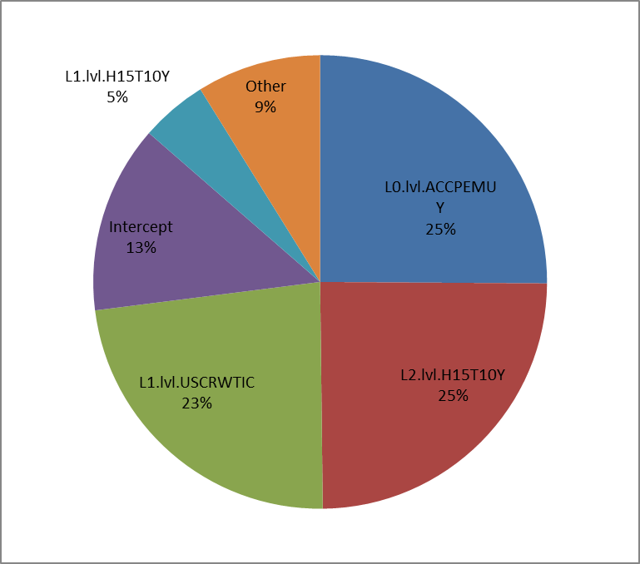

Figure 9: Variables contribution to the parent model after stacking aggregation

Figure 10 and Figure 11 Figure 5show in sample and out of sample backtests using alternative aggregation methods. The out of sample prediction is based on a KFold bootstrapping; iteratively removing 4 successive points from the training set on which the models are recalibrated. Afterwards, prediction is done on the 4 removed points. These figures show relatively close performance between Stacking, BMA and arithmetic average when testing In Sample whereas Stacking is significantly superior on the out of sample test.

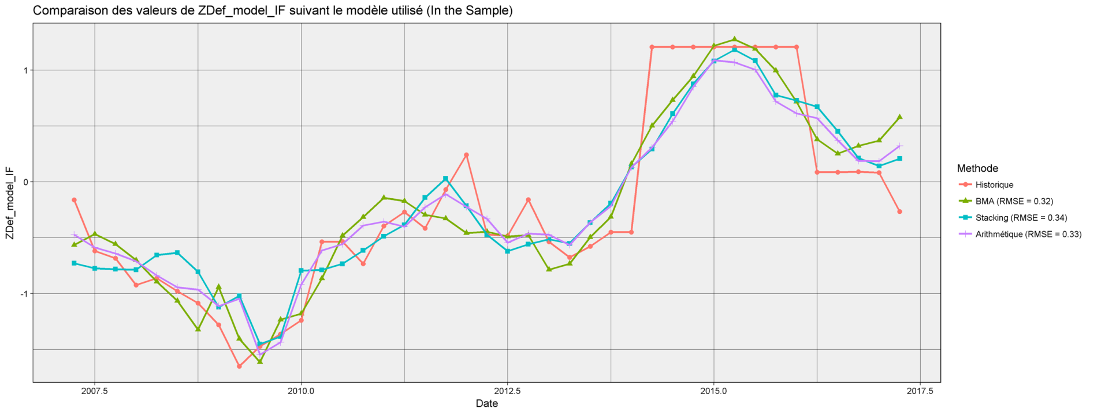

Figure 10: In sample backtests for FI Default systemic indicator models using different aggregation methods.

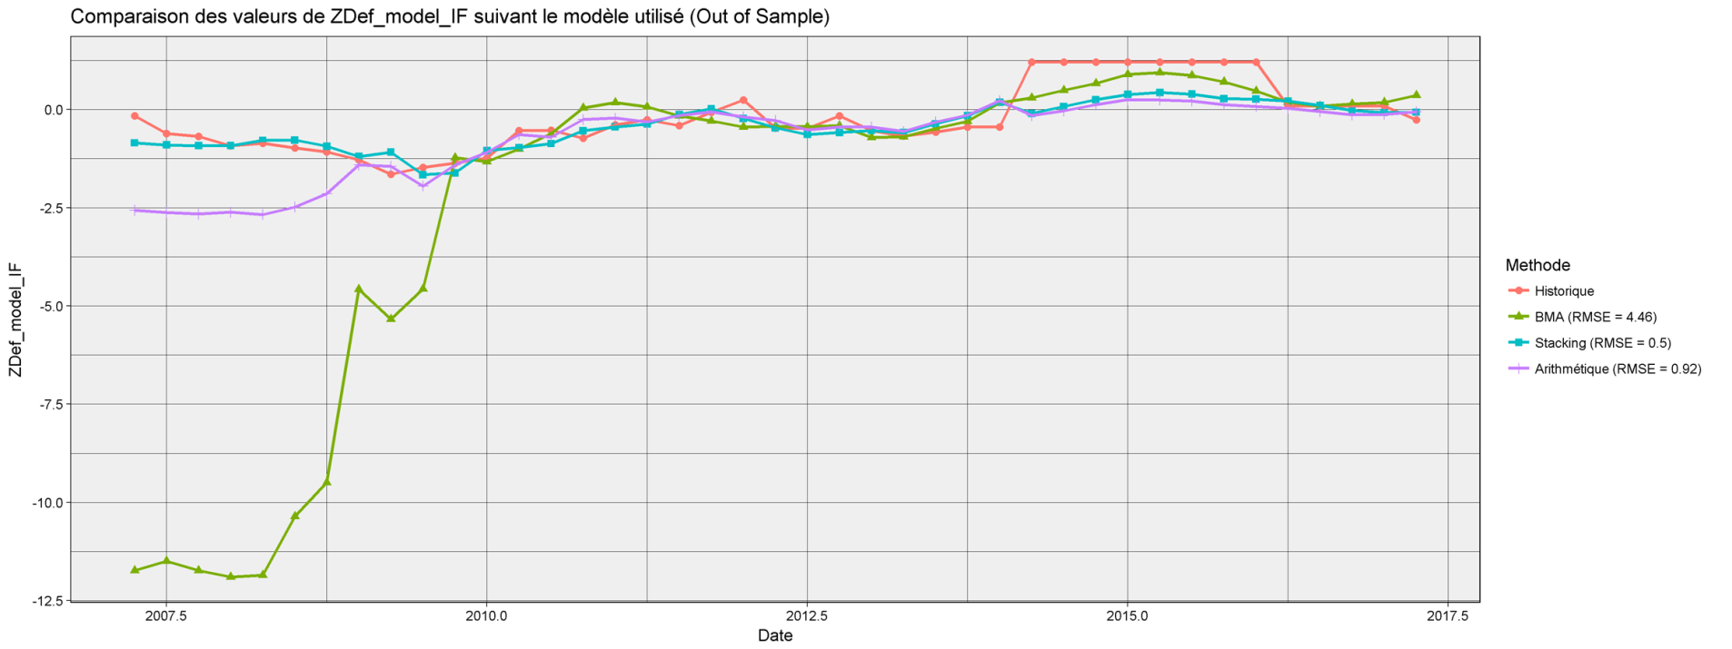

Figure 11: Out of sample backtests for FI Default systemic indicator models using different aggregation methods.

### Migration Systemic Indicator

This section aims at describing the model for financial institutions migration Systemic Indicator calibration and showing its performance.

The final model equation is given in the table below.

|  |  |  |
| --- | --- | --- |
| Variable | Description | Coefficient (Weighted average) |
| Intercept | - | 0.2816 |
| L0.lvl.ecarttauxlongcourtUSD | Spread between 10Y and 3M US bond yield | -0.1206 |
| L2.lvl.USCRWTIC | Oil price WTI | -0.0027 |
| L1.lvl.GFRN10 | France Govt Oats Btan 10 Y | 0.0406 |
| L0.lvl.USCRWTIC | Oil price WTI | -0.001 |
| L2.lvl.USURTOT | US Unemployment Rate Total In Labor Force | -0.0105 |
| L0.rdt.H15T10Y | US Treasury Yield Curve Rate T Note Constant Maturity 10 Year | -0.2127 |
| L1.lvl.HPIMLEVL | Federal Housing Finance Agency US House Price Index Purchase Only | 0.0002 |
| L2.lvl.GDP.CYOY | real GDP GA – US | 0.0238 |
| L2.rdt.SPX | SPX | 0.4945 |
| L2.rdt.UMRTFR | Corrected unemployment rate - France | -1.614 |
| L0.rdt.GFRN10 | France Govt Oats Btan 10 Y | 0.1268 |
| L0.lvl.FRCPIYOY | CPI GA – France | 0.0187 |
| L2.rdt.BDIY | Baltic Dry Index | -0.1494 |
| L2.lvl.EUGNEMUY | real GDP GA - Zone euro | 0.0229 |
| L0.lvl.FDTR | Central Bank rate- US | 0.0229 |
| L0.rdt.HPIMLEVL | Federal Housing Finance Agency US House Price Index Purchase Only | -1.9313 |
| L2.rdt.OCONTWLD | Oil world consumption | 1.3871 |
| L1.lvl.tedSpread | Spread between Libor and government rates 3M | 0.0298 |
| L2.lvl.US0003M | US Libor 3 month | 0.0061 |
| L1.rdt.H15T3M | US Treasury Yield Curve Rate T Note Constant Maturity 3 Month | 0.0297 |
| L0.lvl.CNFREXPY | China Export Trade (Annual YoY %) | 0.0011 |
| L1.lvl.US0003M | US Libor 3 month | 0.0068 |
| L0.rdt.SPX | S&P 500 | 0.1366 |
| L1.rdt.GFRN10 | France Govt Oats Btan 10 Y | 0.0326 |
| L2.rdt.UMRTEMU | unemployment rate seasonally adjusted - Zone euro | -0.2396 |
| L1.rdt.FRGEGDPY | real GDP GA – France | 0.0549 |
| L0.rdt.FDTR | Central Bank rate- US | -0.0259 |
| L0.rdt.GDP.CYOY | real GDP GA – US | 0.0319 |
| L0.rdt.FRCPIYOY | CPI GA – France | 0.024 |
| L2.rdt.CPI.YOY | CPI GA – US | 0.0081 |
| L2.rdt.US0003M | US Libor 3 month | 0.0018 |
| L1.rdt.UMRTEMU | unemployment rate seasonally adjusted - Zone euro | -0.0227 |
| L2.rdt.FDTR | Central Bank rate- US | -0.0025 |
| L1.rdt.FRHPI | Federal Housing Finance Agency FR House Price Index Purchase Only | 0.0189 |
| L1.rdt.SXXE | Euro Stoxx | 0.4677 |

More than 3000 models were accepted with a 95% confidence level using statistical tests and economic constraints.

|  |  |  |  |  |  |  |  |
| --- | --- | --- | --- | --- | --- | --- | --- |
| Model name | RMSE | R² | R² adj | AIC | BIC | p-value test Fisher | max(p-value) test Student |
| ~L0.lvl.H15T3M + L1.lvl.GFRN10 + L2.lvl.USCRWTIC | 0.60 | 0.50 | 0.46 | 88.85 | 97.42 | 8.54E-06 | 4.51E-02 |
| ~L0.lvl.UMRTFR + L0.lvl.H15T3M | 0.60 | 0.50 | 0.47 | 87.51 | 94.37 | 2.27E-06 | 9.03E-03 |
| ~L0.lvl.GFRN10 + L0.lvl.HPIMLEVL + L0.rdt.H15T10Y | 0.61 | 0.55 | 0.51 | 84.76 | 93.33 | 1.40E-06 | 1.97E-03 |
| ~L1.lvl.GFRN10 + L1.rdt.FDTR + L2.lvl.USURTOT | 0.61 | 0.53 | 0.50 | 86.16 | 94.73 | 2.61E-06 | 7.65E-04 |
| ~L0.rdt.GFRN10 + L0.rdt.H15T10Y + L1.lvl.CPUPXYOY | 0.61 | 0.52 | 0.48 | 87.46 | 96.03 | 4.63E-06 | 2.22E-03 |
| ~L0.lvl.H15T3M + L0.rdt.HPIMLEVL | 0.61 | 0.48 | 0.45 | 88.63 | 95.48 | 3.81E-06 | 2.02E-03 |
| ~L0.lvl.H15T3M + L1.lvl.GFRN10 + L2.rdt.USCRWTIC | 0.61 | 0.48 | 0.44 | 90.82 | 99.39 | 2.03E-05 | 3.08E-02 |
| ~L0.lvl.FDTR + L0.rdt.HPIMLEVL | 0.61 | 0.50 | 0.47 | 87.39 | 94.25 | 2.15E-06 | 2.18E-03 |
| ~L0.lvl.H15T3M + L1.lvl.UMRTEMU + L2.rdt.BDIY | 0.62 | 0.49 | 0.45 | 89.87 | 98.44 | 1.34E-05 | 1.37E-02 |
| ~L1.rdt.FDTR + L2.lvl.US0003M + L2.lvl.FDTR | 0.62 | 0.56 | 0.53 | 83.69 | 92.25 | 8.74E-07 | 4.30E-02 |

Table 7: Best accepted models according to out of sample rmse (10 out of 6559) for FI migration systemic indicator

The used model is a weighted average stacking of the models above. Table 8 lists the most weighted models when aggregating models using Stacking. Note that individual R² are fewer than 51% whereas the aggregated model reaches 59%.

|  |  |  |  |  |  |  |  |  |
| --- | --- | --- | --- | --- | --- | --- | --- | --- |
| Model Name | Stacking weight | RMSE | R² | R² adj | AIC | BIC | Fisher Snedecor PValue | Max Student PValue |
| ~L0.rdt.HPIMLEVL + L2.rdt.BDIY + L2.rdt.SPX | 15% | 0.96 | 0.42 | 0.38 | 94.87 | 103.44 | 1.20E-04 | 5.50E-03 |
| ~L0.lvl.ecarttauxlongcourtUSD + L0.rdt.GDP.CYOY + L1.lvl.BDIY | 14% | 0.99 | 0.41 | 0.37 | 95.66 | 104.23 | 1.69E-04 | 7.17E-03 |
| ~L0.rdt.GFRN10 + L0.rdt.H15T10Y + L2.lvl.GDP.CYOY | 10% | 1.09 | 0.51 | 0.47 | 88.64 | 97.21 | 7.79E-06 | 9.58E-04 |
| ~L0.rdt.H15T10Y + L2.lvl.EUGNEMUY + L2.lvl.USCRWTIC | 9% | 0.71 | 0.48 | 0.44 | 90.63 | 99.20 | 1.87E-05 | 1.20E-02 |
| ~L1.rdt.SXXE + L1.rdt.FRGEGDPY + L2.rdt.UMRTFR | 7% | 0.93 | 0.40 | 0.35 | 96.59 | 105.16 | 2.53E-04 | 4.04E-04 |
| ~L0.lvl.USCRWTIC + L1.lvl.GFRN10 + L1.rdt.H15T3M | 7% | 0.83 | 0.39 | 0.34 | 97.25 | 105.82 | 3.38E-04 | 2.82E-02 |
| ~L0.rdt.GFRN10 + L0.rdt.H15T10Y + L2.lvl.EUGNEMUY | 6% | 0.70 | 0.44 | 0.39 | 93.85 | 102.42 | 7.67E-05 | 1.23E-02 |
| ~L0.lvl.FDTR + L0.rdt.FDTR + L1.rdt.SXXE | 6% | 1.59 | 0.53 | 0.50 | 86.32 | 94.89 | 2.80E-06 | 3.69E-02 |
| ~L0.rdt.FRCPIYOY + L1.rdt.GFRN10 + L2.rdt.OCONTWLD | 4% | 0.87 | 0.39 | 0.34 | 97.06 | 105.62 | 3.10E-04 | 4.89E-02 |
| ~L0.rdt.SPX + L0.rdt.H15T10Y + L2.rdt.UMRTEMU | 4% | 1.08 | 0.33 | 0.27 | 101.34 | 109.91 | 1.98E-03 | 3.55E-02 |

Table 8: Most weighted models after stacking procedure

Parent model could be summarized to a unique equation by averaging coefficients. Therefore, the contribution of each variable to the model could be assessed as the average contribution to the historical estimation. Figure 12 shows FI default is mainly explained by the spread between long and short term US treasury rates (18%), oil price WTI (15% lag 2 + 5% no lag), 10Y French government bonds yield (8%), US unemployment rate (5% lag 2) and additional contributions from different variables.

Note that the model ~L1.rdt.SXXE.Index+L1.rdt.FRGEGDPY.Index+L2.rdt.UMRTFR.Index has a VIF of 9.83. Another sub model has a VIF of 5.11, with a weight of 0.3%.

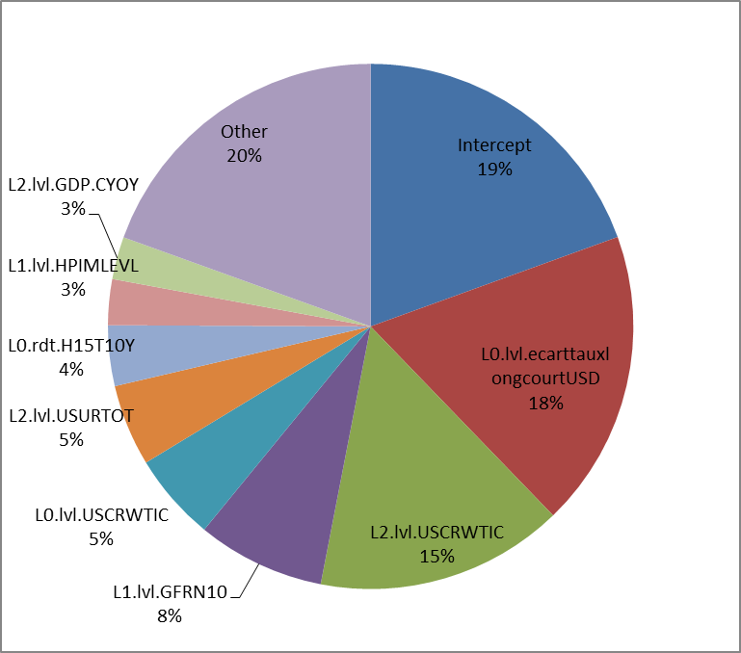

Figure 12: Variables contribution to the parent model after stacking aggregation

Figure 13 and Figure 14 show in sample and out of sample backtests using alternative aggregation methods. The out of sample prediction is based on a KFold bootstrapping; iteratively removing 4 successive points from the training set on which the models are recalibrated. Afterwards, prediction is done on the 4 removed points. These figures show relatively close performance between Stacking, BMA and arithmetic average when testing In Sample whereas Stacking is significantly superior on the out of sample test.

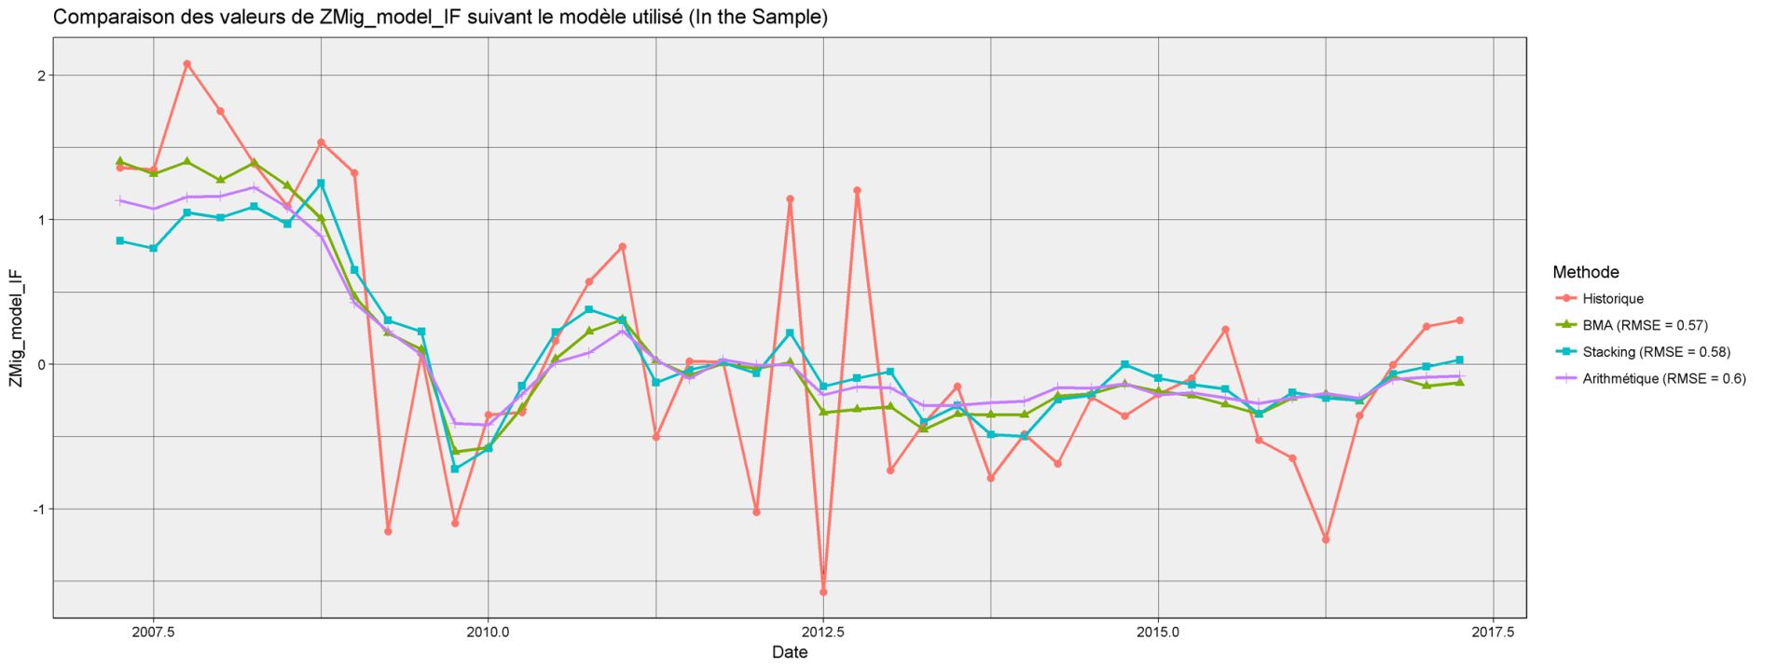

Figure 13: In sample backtests for FI Migration systemic indicator models using different aggregation methods.

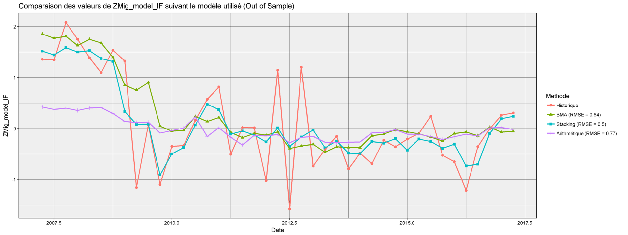

Figure 14: Out of sample backtests for FI Migration systemic indicator models using different aggregation methods.

# Procedure

## Model projection inputs

* Corporate and FI systemic variables for default and migration:
  + Data source: Internal migration database
  + Automatically calculated using R script
* Historical macroeconomic data:
  + Data provider: Bloomberg
  + Data download: Bloomberg automatic extract using Excel API
* Macroeconomic projections:
  + Data source: CASA ECO excel file (Baseline and Adverse scenarios). CASA ECO projects the macroeconomic variables for 3 years.
  + Formatting: Manual formatting in excel
  + Controls:
    - Manually compare current levels between CASA ECO file and Bloomberg
    - Analyzing projection values and ensuring the correct interpretation of the ticker (level vs. growth, unit and average vs. yearend value)
    - Ensuring no data is missing

## Model projection outputs

An automated exhaustive search is run which lead to a calibrated “parent model”. The “parent model” consumes the macroeconomic projections (3 years) and projects 3 years forward looking / stressed systemic variables which are automatically transformed to PD and LGD.

## Outputs adjustments

The projection is not guaranteed to respect scenario’s hierarchy. For example, baseline projection could be more stressed than an adverse scenario for some maturities. For this reason, baseline scenario is considered the reference and all other scenarios are subject to cap or floor adjustments for respecting their hierarchy with the baseline scenario.

# Results

The projection model outputs are projected systemic indices and for corporate and Financial institutions. 3 years projections are obtained. Note that the baseline projection is overall higher than adverse projection but this order is not systematic. This is mainly due to some inversions in the input scenario, the baseline scenario is made to be less stressed than the adverse while cumulating the 3 years but not for every year. These projections are used to produce forward looking / stressed migration matrices, default probability term structure and forward looking LGD. These processes are described in the document “CACIB - IFRS 9 - Forward Looking Integration to ECL”.

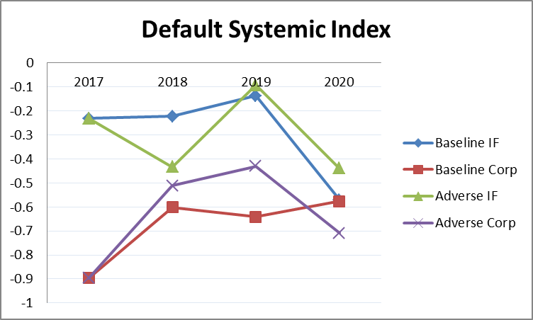

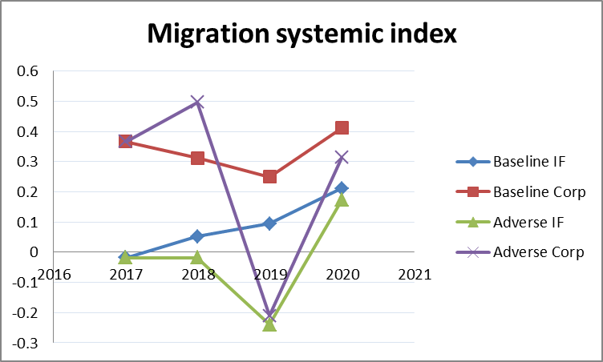

# Bibliography

|  |  |
| --- | --- |
| [1] | J. H. a. R. M. Stéphane Dees, "STAMP€: Stress-Test Analytics for Macroprudential Purposes in the euro area," European Central Bank, 2017. |

1. for each combination of regression